Get Ahead! Level 1 Carpentry and Joinery
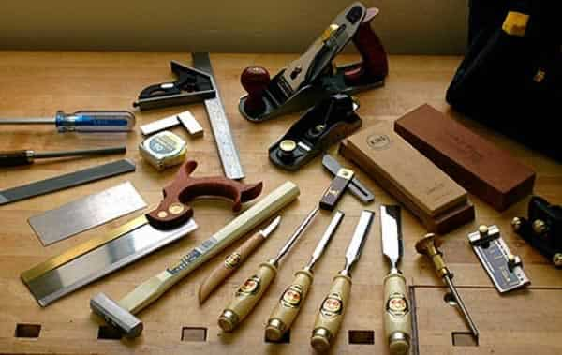
Working in the carpentry and joinery industry, can be an interesting and rewarding career. You could go from fitting a kitchen in someone’s home. To building a treehouse in the middle of a forest. But before that you must develop your skills and knowledge

WHAT WILL I LEARN IN LEVEL 1 ?
Joinery is an industry that is constantly changing with new methods and tools being developed all the time. But one thing that never changes is basic hand skills and working in a safe manner with numerous hand and power tools.
You will develop these by first doing some simple wood joints. Such as bridle joints half laps and mortice and tenon Joints
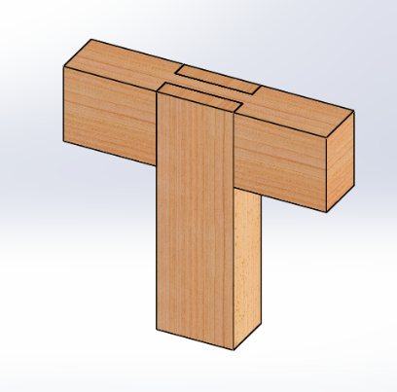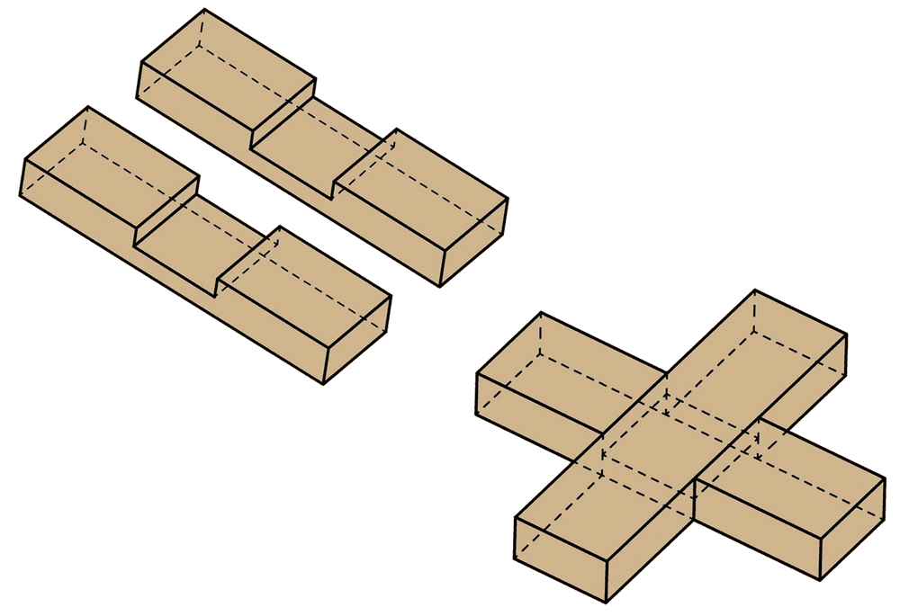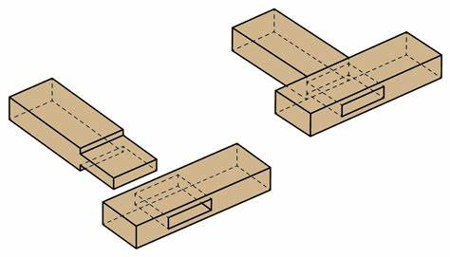

And when all these are completed you will move on to more complex tasks which may also include some of your own ideas such as picture frames, wishing well planters and other tasks to get you hand skills and tool knowledge ready to move on to level 2.

WHAT ELSE WILL I LEARN ?
You will gain knowledge the importance of health and safety in the construction industry. Construction can be a fantastic career and take you all over the world, but is also dangerous and you must work in a safe manner. You will be taught all about working in a safe manner and building regulations.

CAN YOU COMPLETE THE SAFETY SIGN BELOW
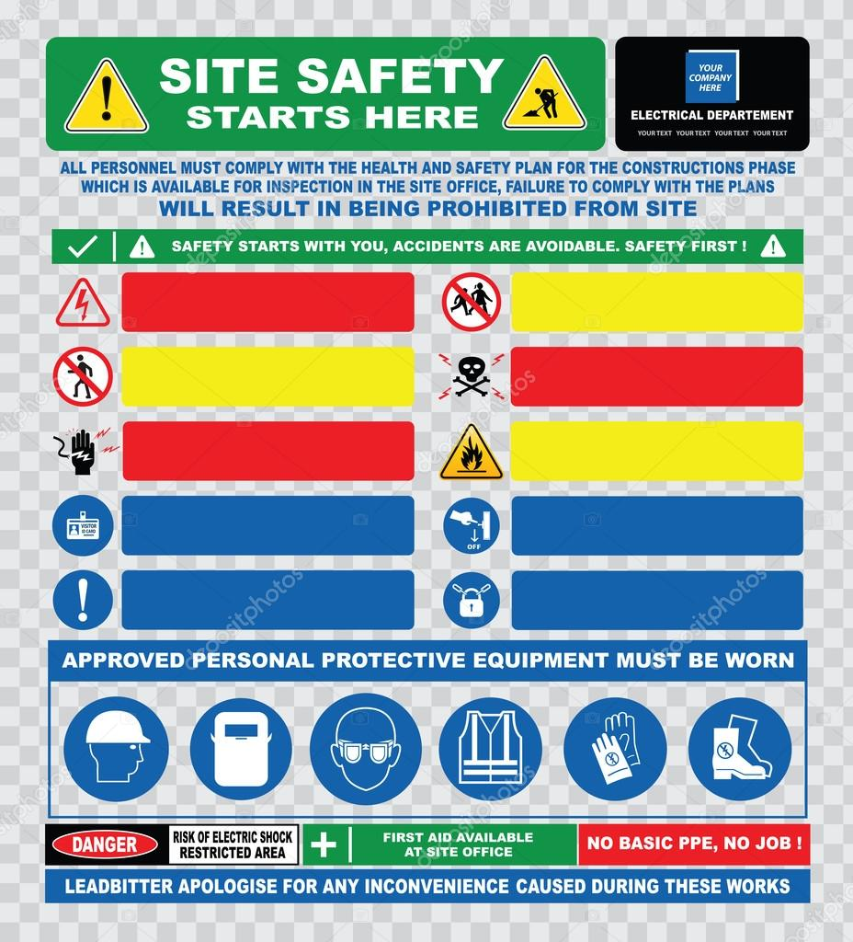

WHAT WILL I GAIN FROM LEVEL 1?
You will gain a lot from level 1 carpentry and joinery setting you up to move on to level 2 where you will start to learn how to hang doors, lay timber floors, fit a roof and many more joinery tasks. It could also help lead towards an apprenticeship.

Finally can you list what hand tools you think a joiner needs?

