Sizing Rainwater Systems.

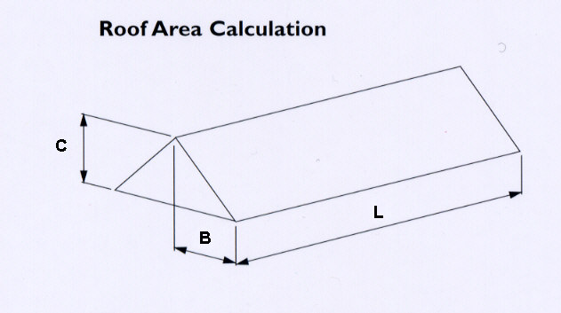

The effective roof area for pitches upto 60o is calculated as follows:

Length of Roof x ½ Full Base of Roof x *Angle Factor* = Effective Roof Area m2



To then calculate the gutter channel and outlet size, refer to the following table:



This is all based on the a high intensity rainfall of 75mm / hour.

* If a roof’s dimensions are as follows, what would the effective roof area be?

10m Length, 4m ½ Base, Pitch of 30 o Effective Area - _________________

15m Length, 2m ½ Base, Pitch of 30 o Effective Area - _________________

8m Length, 5m ½ Base, Pitch of 30 o Effective Area - _________________

20m Length, 4m ½ Base, Pitch of 45 o Effective Area - _________________

10m Length, 4m ½ Base, Pitch of 60 o Effective Area - _________________

* What would the gutter channel size be for the first two scenarios?

10m Length, 4m ½ Base, Pitch of 30 o Gutter Size - _________________

15m Length, 2m ½ Base, Pitch of 30 o Gutter Size - _________________

* What would the outlet size be for the next two scenarios?

8m Length, 5m ½ Base, Pitch of 30 o Outlet size - _________________

20m Length, 4m ½ Base, Pitch of 45 o Outlet size - _________________

* What would the flow capacity be for the final scenario?

10m Length, 4m ½ Base, Pitch of 60 o Flow Capacity - _________________